**Aim:**

To demonstrate virtualization by installing a Type-2 hypervisor (VirtualBox) on a host device and creating/configuring a Virtual Machine (VM) with a host operating system (either Windows/Linux).

**Procedure:**

Install Type-2 Hypervisor (VirtualBox):

* Download Oracle VirtualBox from the official website.
* Run the setup file and install it with default settings.
* Ensure that virtualization is enabled in the BIOS/UEFI of the host machine.

Create a New Virtual Machine (VM):

* Open VirtualBox → Click New.
* Provide a name for the VM and select the type of operating system (Windows/Linux).
* Allocate RAM (e.g., 2GB or more depending on host capacity).
* Create a Virtual Hard Disk (VHD) with sufficient storage (e.g., 20GB).

Configure VM Settings:

* Attach the ISO file of the chosen operating system (Windows/Linux) as the boot disk.
* Adjust CPU, display, and network settings as required.

Install Operating System in VM:

* Start the VM, and the ISO file will boot.
* Follow installation steps to install the chosen OS inside the virtual machine.

Verify Virtualization:

* After successful installation, log in to the VM.
* Check system details of the VM to confirm the OS installation.
* Test basic operations (file creation, internet access, etc.) inside the VM.

**OUTPUT:**

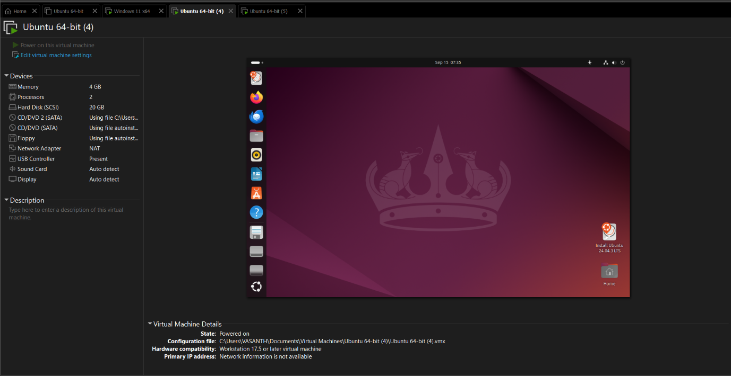

**Result:**

Virtualization was successfully demonstrated by installing a Type-2 hypervisor (VirtualBox), creating and configuring a VM, and installing a host operating system (Windows/Linux) in it.